

Student Name: KABURU EVANS MUTHOMI
Admission Number: BSCCS/2024/62210
Course/Class: Bachelors of Science in Computer Science
Unit Code: BIT4138
Unit Name: Advanced Cryptography
Lecturer Name: Michael Nyoro
Semester/Academic Year: May/August 2026

GitHub Repository Link:
https://github.com/mthomikaburu

Contents
Stream Ciphers and Randomness Testing 3
Implementation of Stream Cipher Systems and Random Sequence Analysis 3
Fig 1: LFSR Generator Implementation 3
Fig 2: Pseudorandom Sequence Output 4
Fig 3: Statistical Randomness Testing 4
Fig 4: RC4 Stream Cipher Simulation 5
Fig 5: Encryption Performance Results 6
Student Reflection 6

Week 3:

Stream Ciphers and Randomness Testing

Implementation of Stream Cipher Systems and Random Sequence Analysis

Fig 1: LFSR Generator Implementation
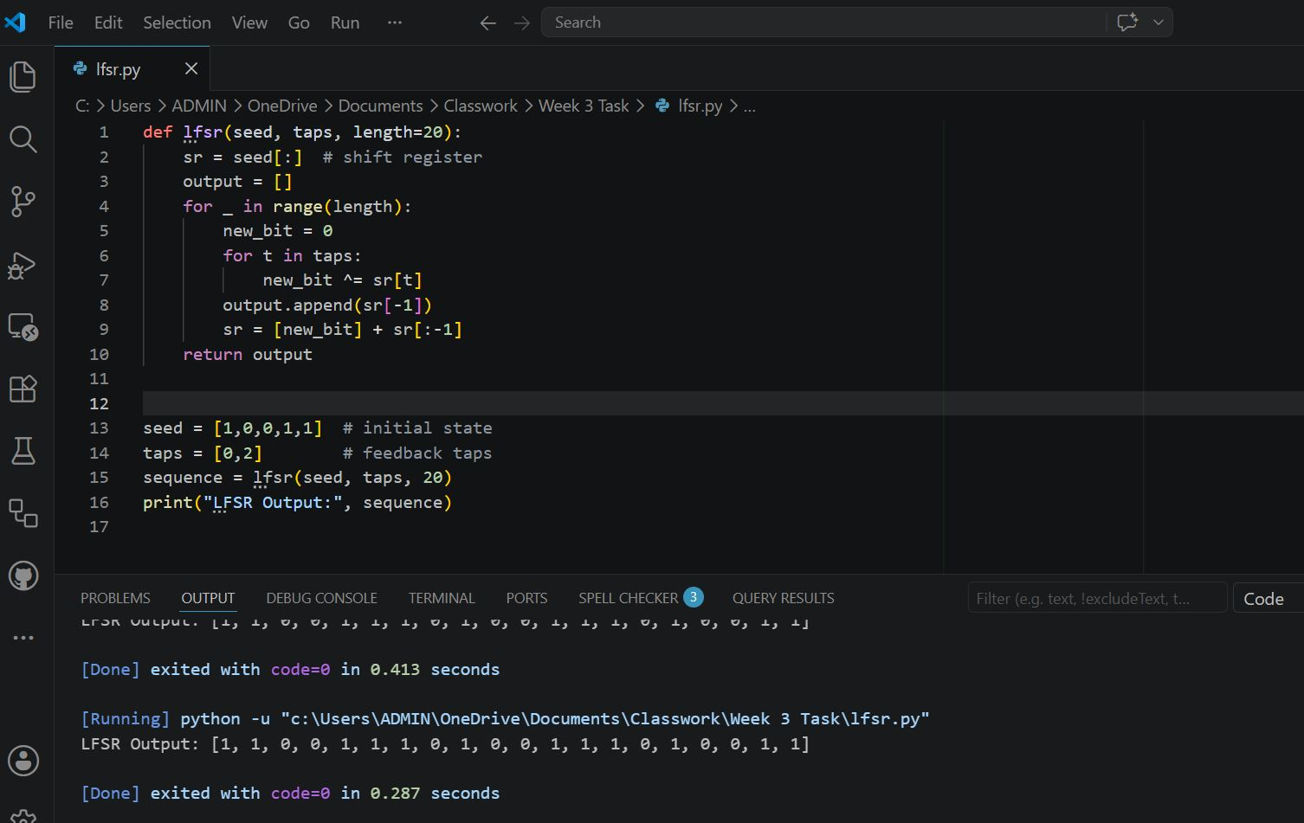

Fig 2: Pseudorandom Sequence Output

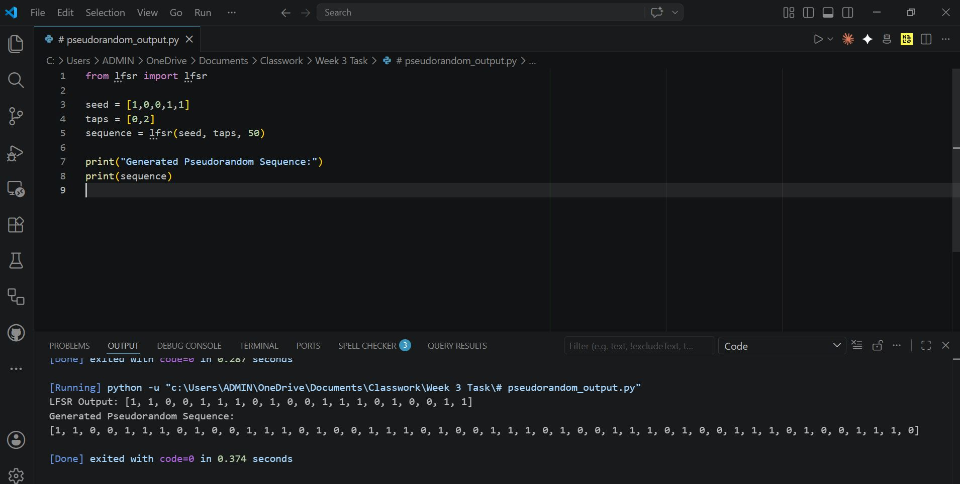

Fig 3: Statistical Randomness Testing

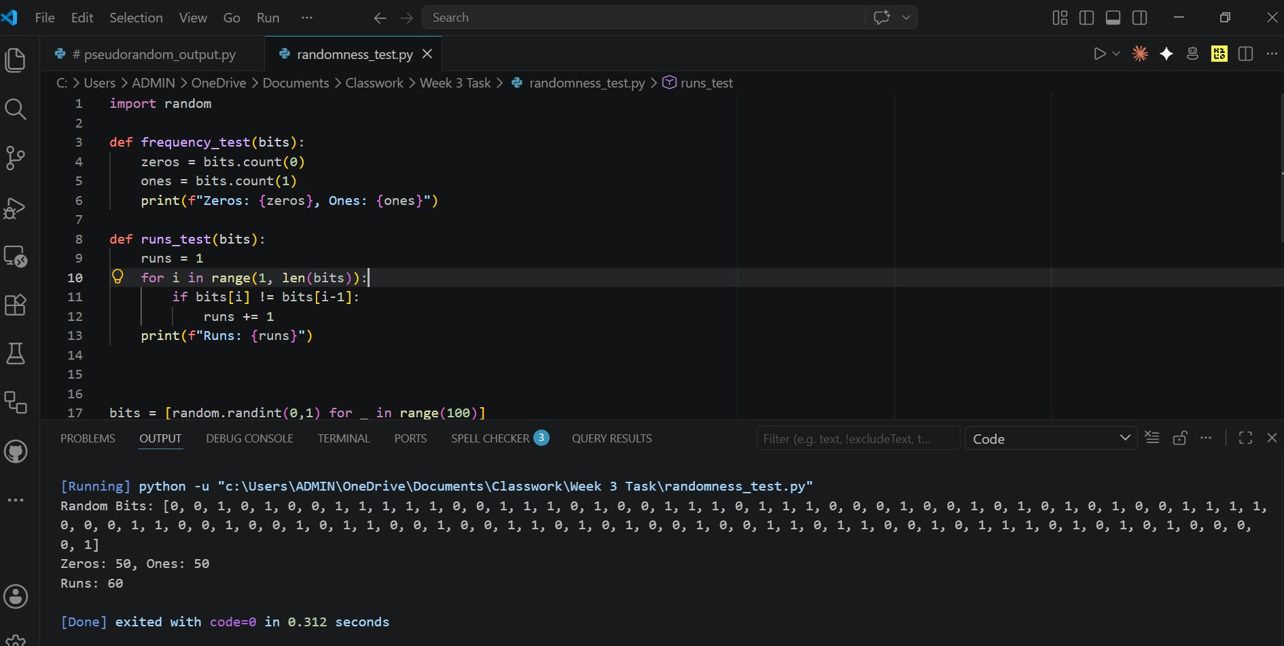

Fig 4: RC4 Stream Cipher Simulation

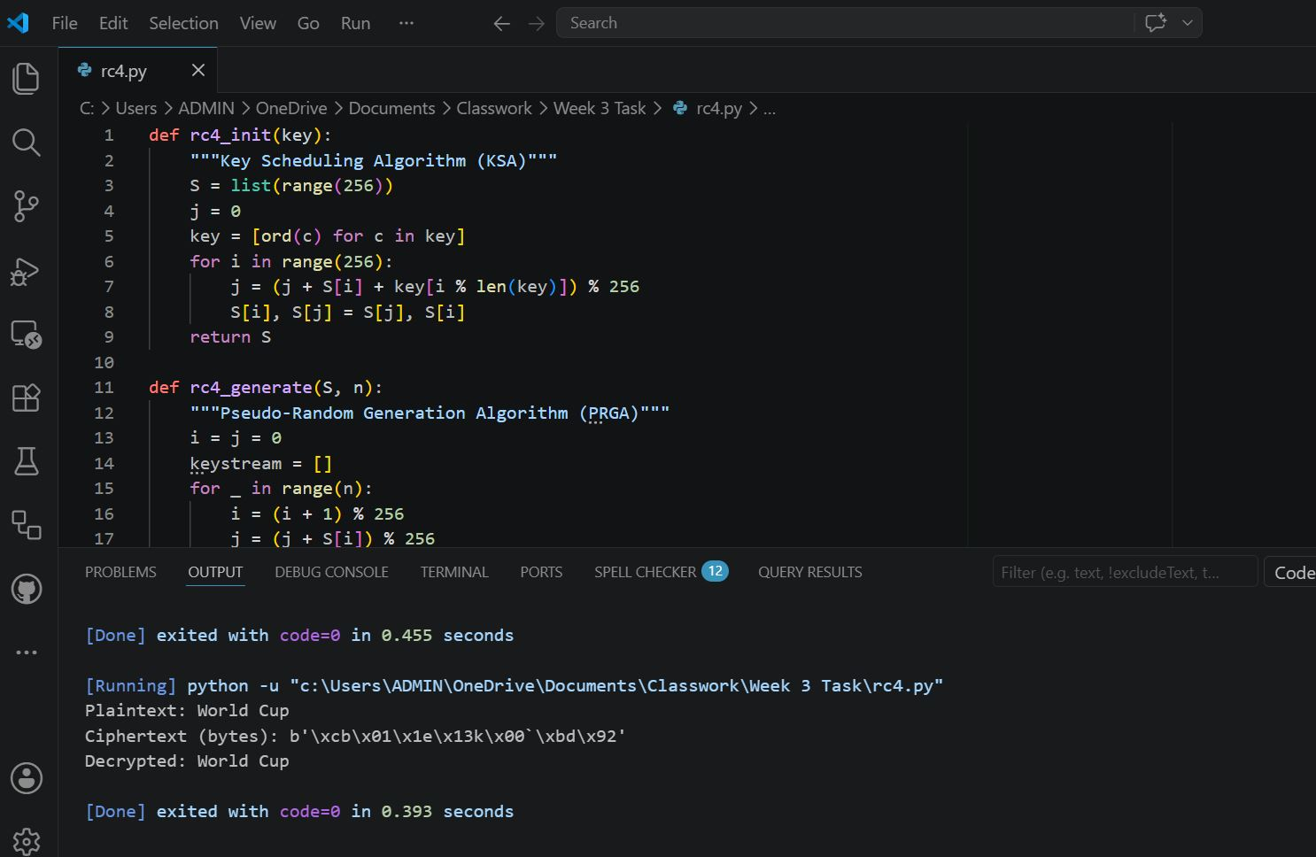

Fig 5: Encryption Performance Results

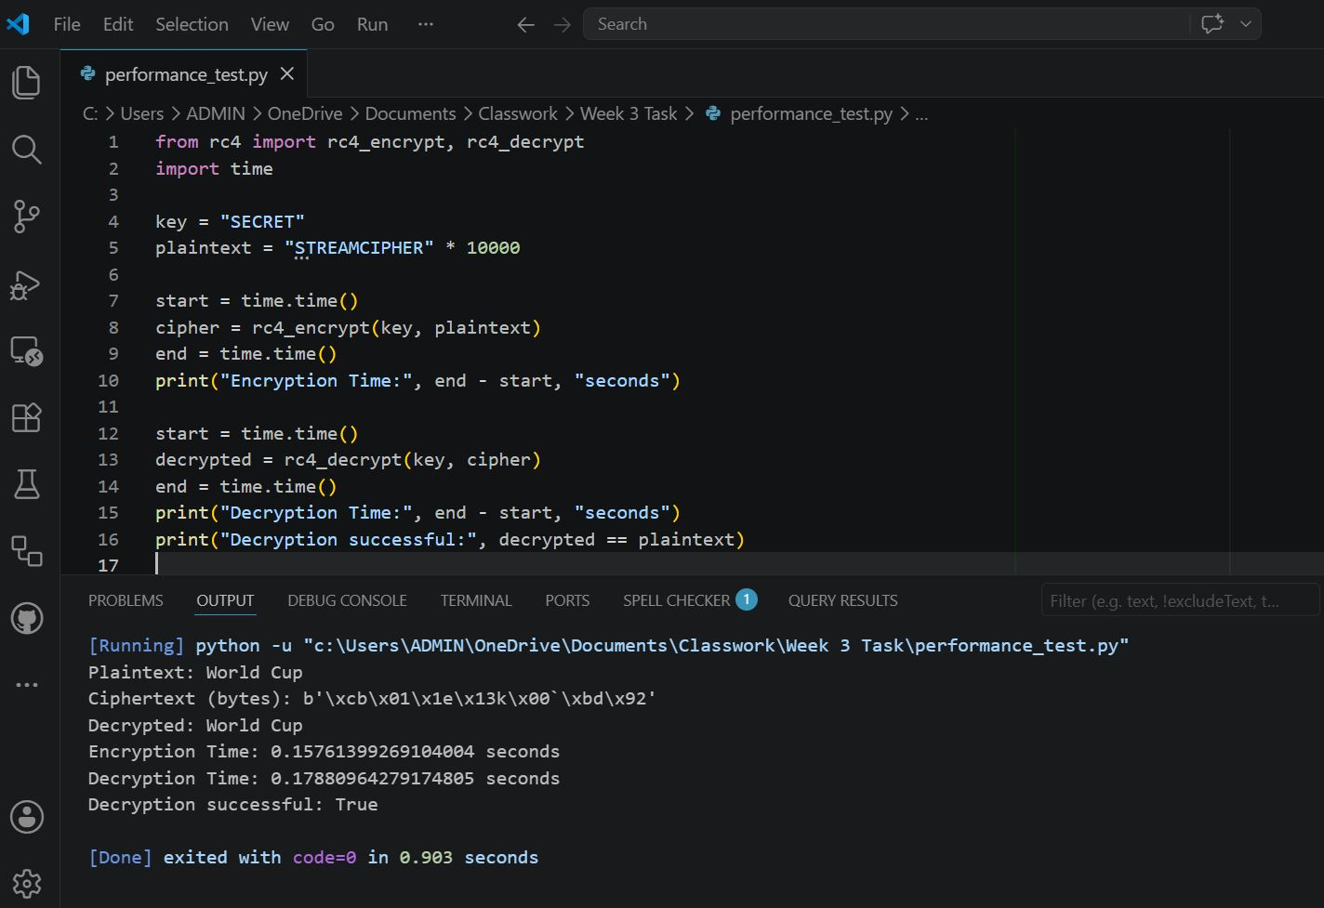

Student Reflection
The RC4 implementation demonstrated real-time stream encryption where data is processed bit-by-bit. Randomness is vital in cryptography to prevent predictability. Statistical tests validated pseudorandom sequence quality. Stream ciphers rely on keystream generation, and weaknesses in randomness highlight the importance of secure pseudorandom generators for strong encryption.

